EXERCISES FOR WINDOWS FORM
Exercise 1: Create a Windows Form application in C# to calculate the sum of two numbers
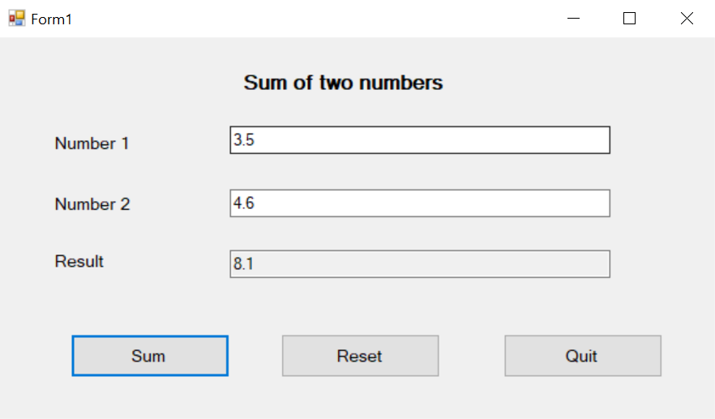
using System;
using System.Collections.Generic;
using System.ComponentModel;
using System.Data;
using System.Drawing;
using System.Linq;
using System.Text;
using System.Threading.Tasks;
using System.Windows.Forms;

namespace Add2Numbers
{
public partial class Form1 : Form
{
public Form1()
{
InitializeComponent();
txtNumber1.Select();
txtResult.ReadOnly = true;
}

private void btnSum_Click(object sender, EventArgs e)
{
double sum = 0;
try
{
sum = double.Parse(txtNumber1.Text) + double.Parse(txtNumber2.Text);
}
catch (Exception ex)
{
MessageBox.Show($"Please enter a number \n {ex.Message}");
}
txtResult.Text = sum.ToString();
}

private void btnQuit_Click(object sender, EventArgs e)
{
this.Close();
}
private void btnReset_Click(object sender, EventArgs e)
{
txtNumber1.Text = "";
txtNumber2.Text = "";
txtResult.Text = "";
}
}
}
Exercise 2:
Accessing website: http://csharp.net-informations.com/
to practice exercises about windows form
C# Graphical User Interface Tutorial
- How to Create a C# Windows Forms Application
- C# Label Control
- C# Button Control
- C# TextBox Control
- C# ComboBox
- C# ListBox Control
- C# Checked ListBox Control
- C# RadioButton Control
- C# CheckBox Control
- C# PictureBox Control
- C# ProgressBar Control
- C# ScrollBars Control
- C# DateTimePicker Control
- C# Treeview Control
- C# ListView Control
- C# Menu Control
- C# MDI Form
- C# Color Dialog Box
- C# Font Dialog Box
- C# OpenFile Dialog Box
- C# Print Dialog Box
- KeyPress event in C# , KeyDown event in C# , KeyUp event in C#
- How to create Dynamic Controls in C#?
- Keep Form on Top of All Other Windows
- C# Timer Control

